
SE-401L Human Computer Interaction Lab
Sir Dr. Hamid Ullah
12 FEB 2026
Ali Khan – 23MDSWE248
UX Honey Comb Lab_01
University of Engineering and Technology Mardan

Lab Title

UX Honey Comb Frame Work

Task: Find a Web Development Service to Create a website for my business.

Selected Website: SkyTech Developers

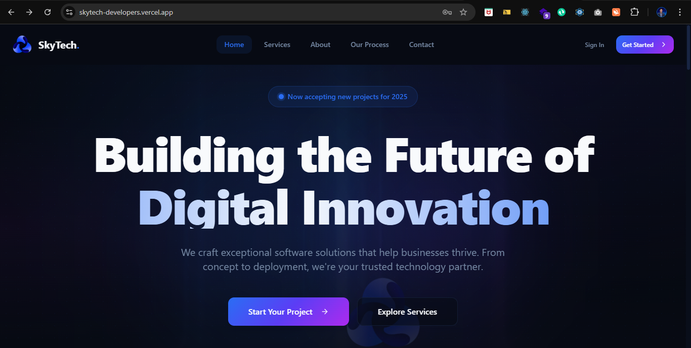
- Useful: Does it clearly explain services?

Yes it clearly explain services and clearly mentioned that they provide web development service so it is usefull.

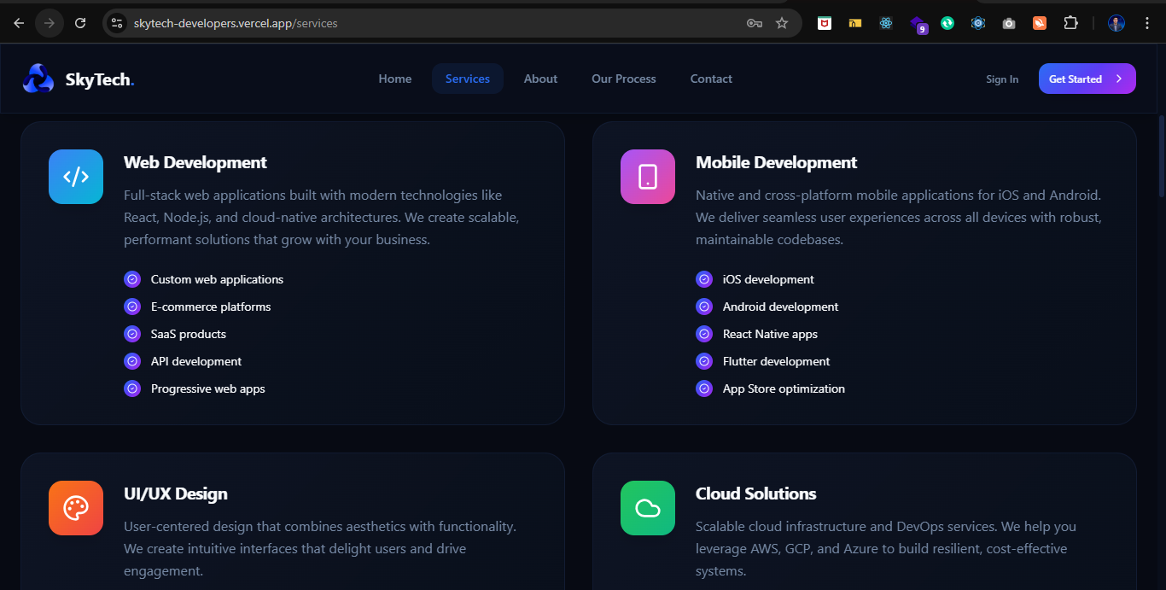
- Usable: Is navigation simple?

Yes navigation is simple and website provide a clear navigation bar.

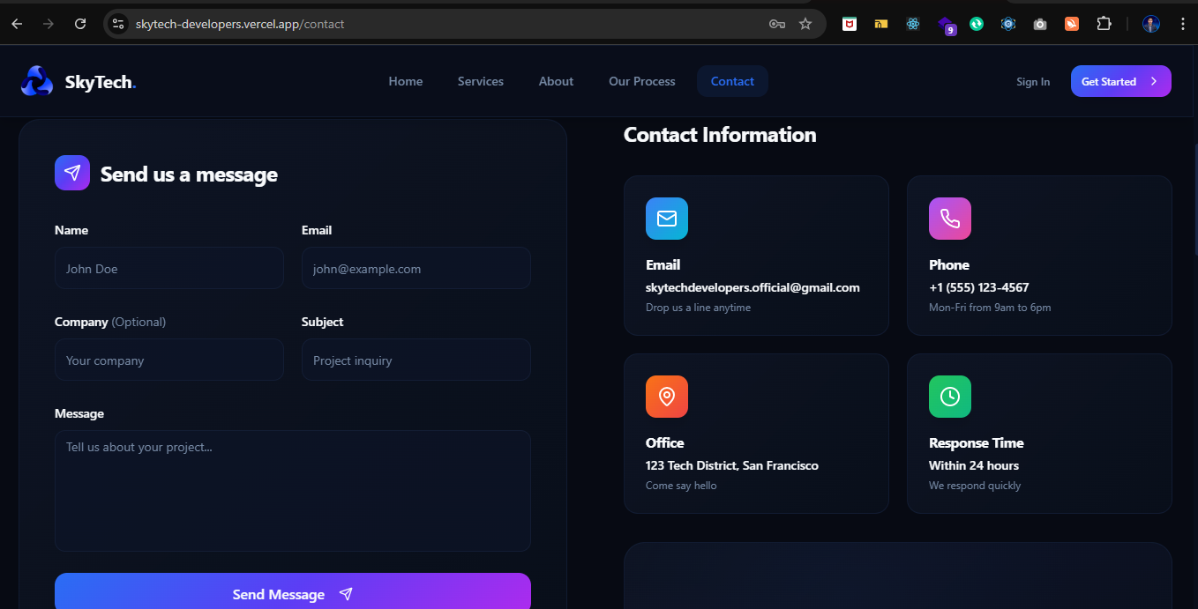
- Desirable: Is design modern and attractive

Yes clean layout, color theme, modern UI and good spacing.

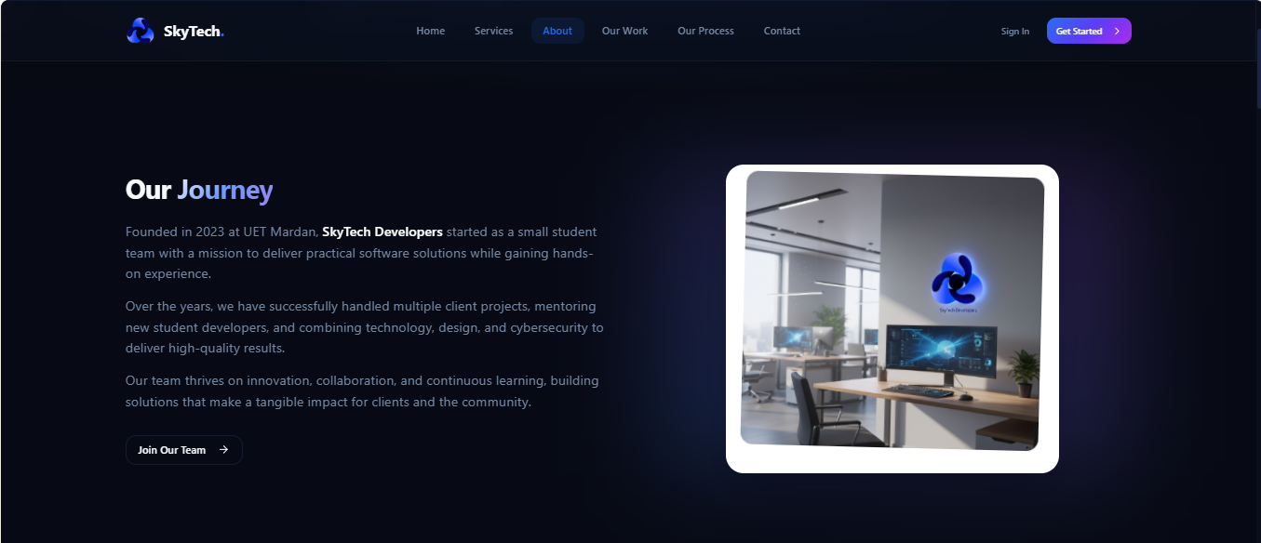

- Findable: Can users easily find contact/services?

Services and contact section are visible but could improve with stronger CTA buttons.

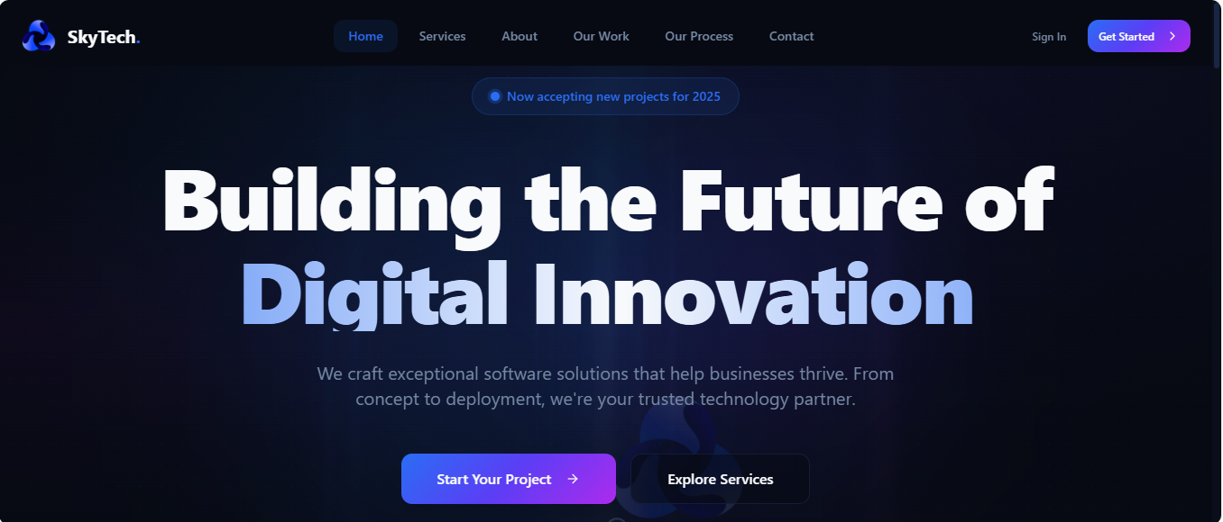

- Accessible: Is text readable? Good contrast?

Font is readable. Needs checking for contrast ration and mobile responsiveness fully.

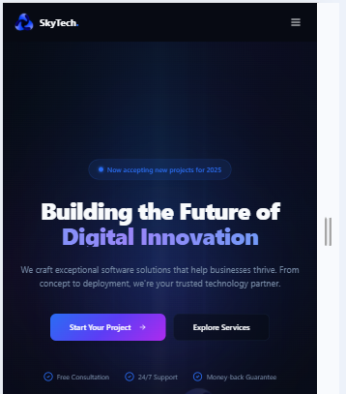

- Credible: Does it build trust?

Showing real projects and team members increases credibility. Testimonials could improve it more.

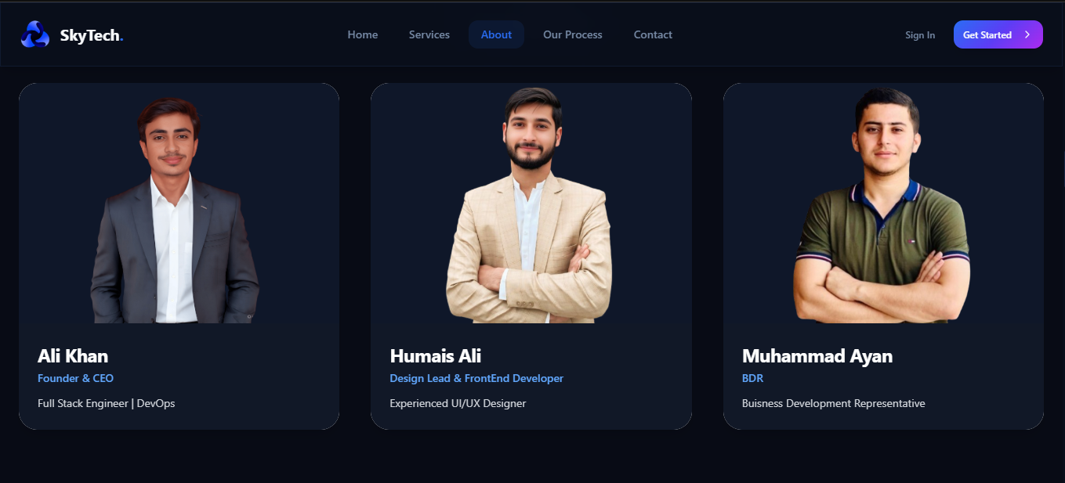

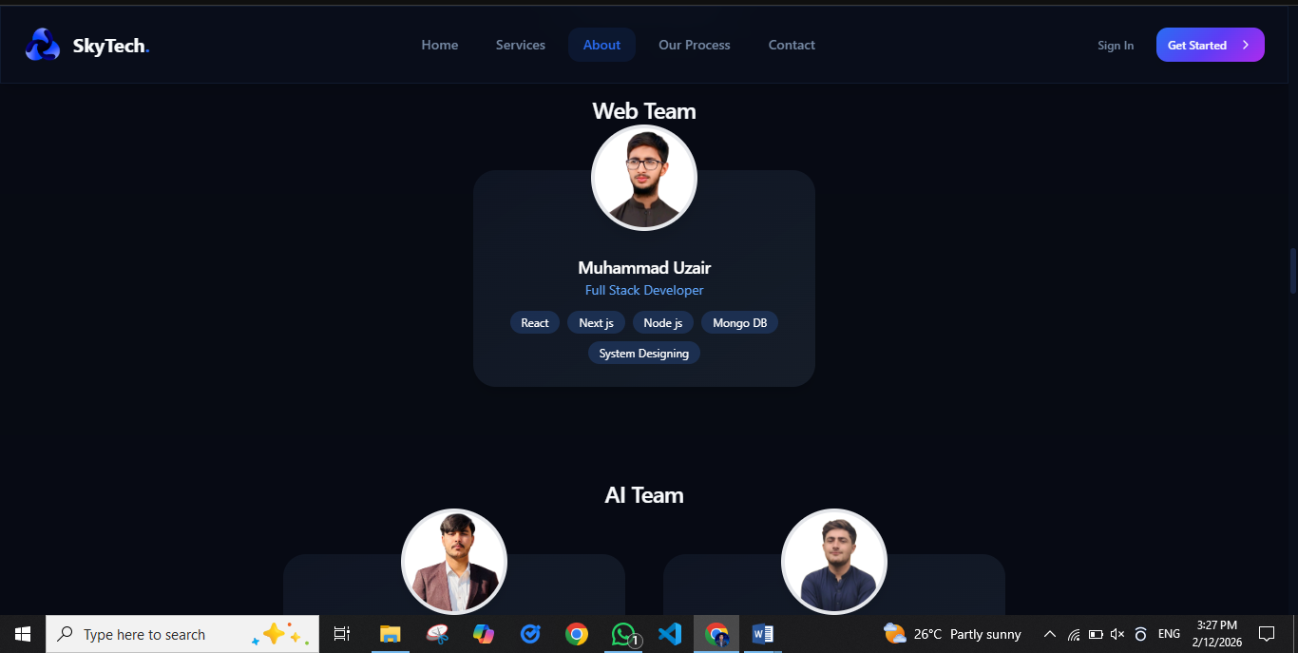

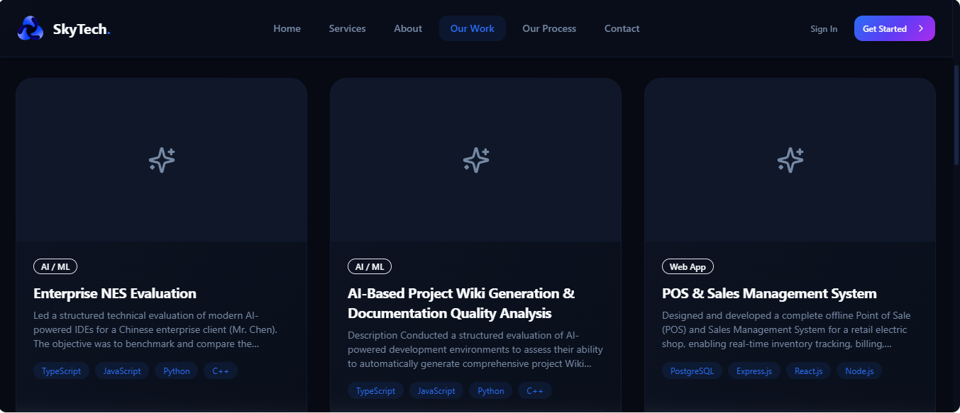

- Valuable: Does it help business goals?

Yes, it presents brand identity and can attract clients.

UX Element | Evaluation Criteria | Picture reference | Observation for SkyTech Website
Useful | Does it clearly explain services? | Service page | Website shows services like web development, projects, and team info → Useful for clients. | ✔
Usable | Is navigation simple? | Menu bar | Navigation menu is simple and understandable. Pages load smoothly. | ✔
Desirable | Is design modern and attractive? | Home page | Clean layout, modern UI, good spacing and colors → Visually appealing. | ✔
Findable | Can users easily find contact/services? | Nav bar  CTA | Services and contact section are visible but could improve with stronger CTA buttons.
Accessible | Is text readable? Good contrast? | Home page | Font is readable. Needs checking for contrast ratio and mobile responsiveness fully. | ✔
Credible | Does it build trust? | Portfolio page | Showing real projects and team members increases credibility. Testimonials could improve it more.
Valuable | Does it help business goals? | Hero section | Yes, it presents brand identity and can attract clients. | ✔

THE END

